Ujian Akhir Semester Praktikum Sistem Basis Data

Fredianto; L200170173

(1)

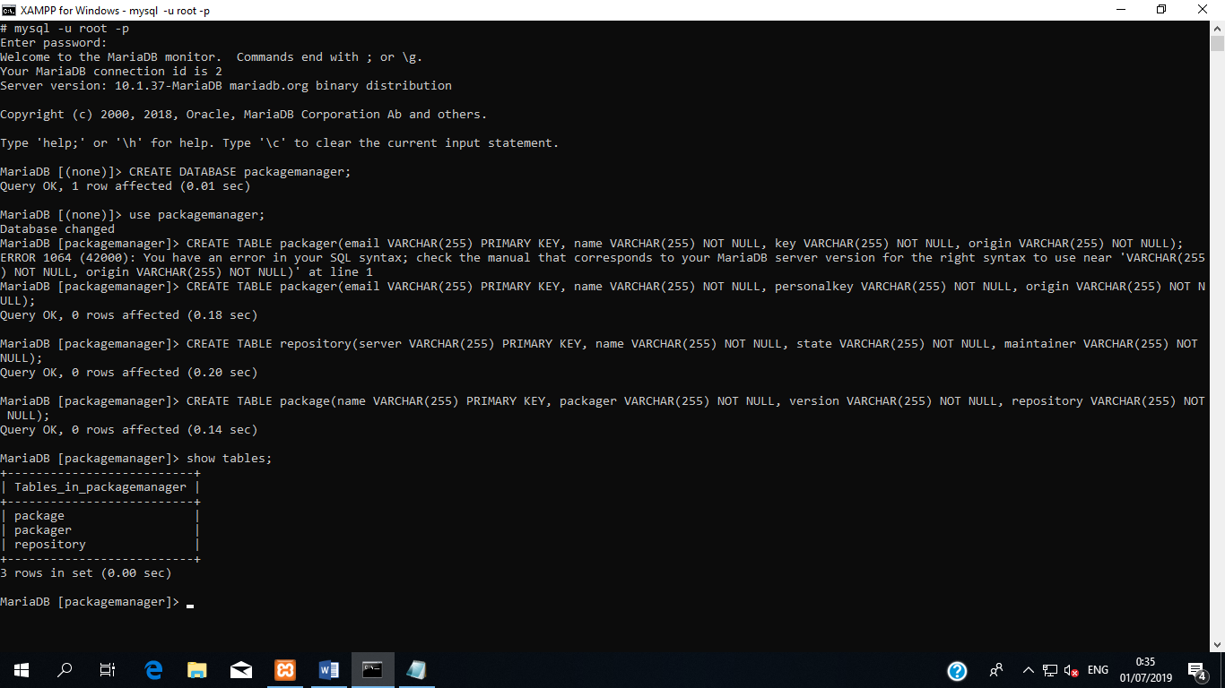

(2)

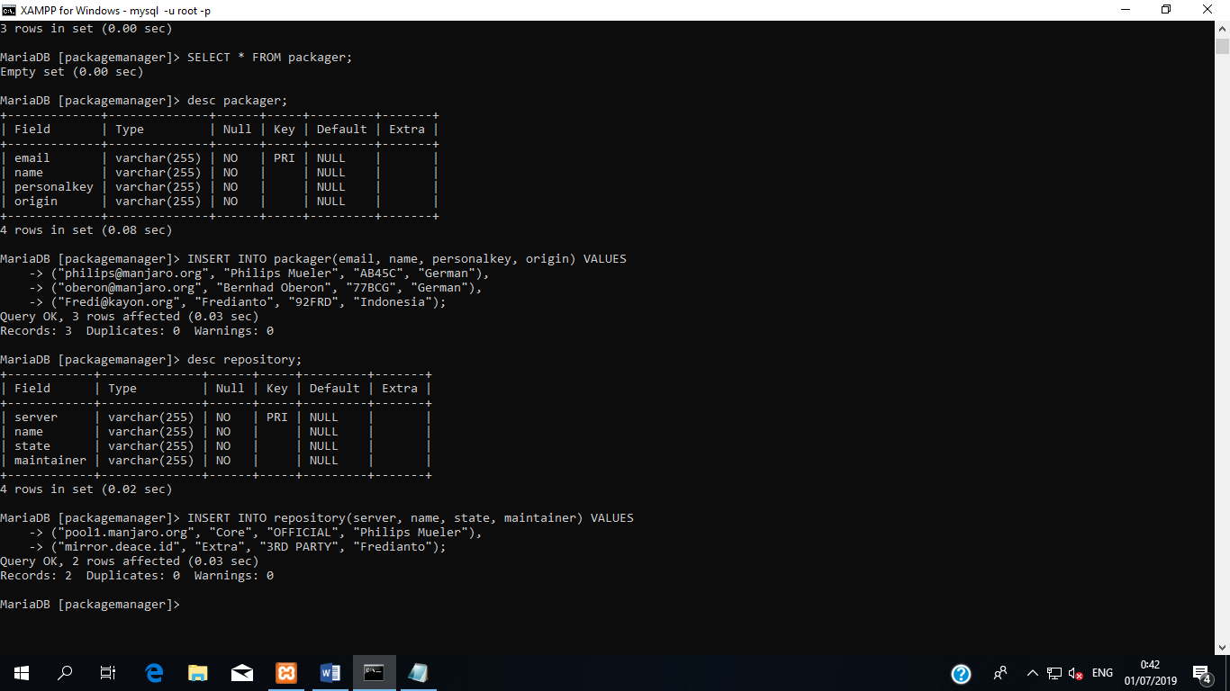

*perintah* ***INSERT***

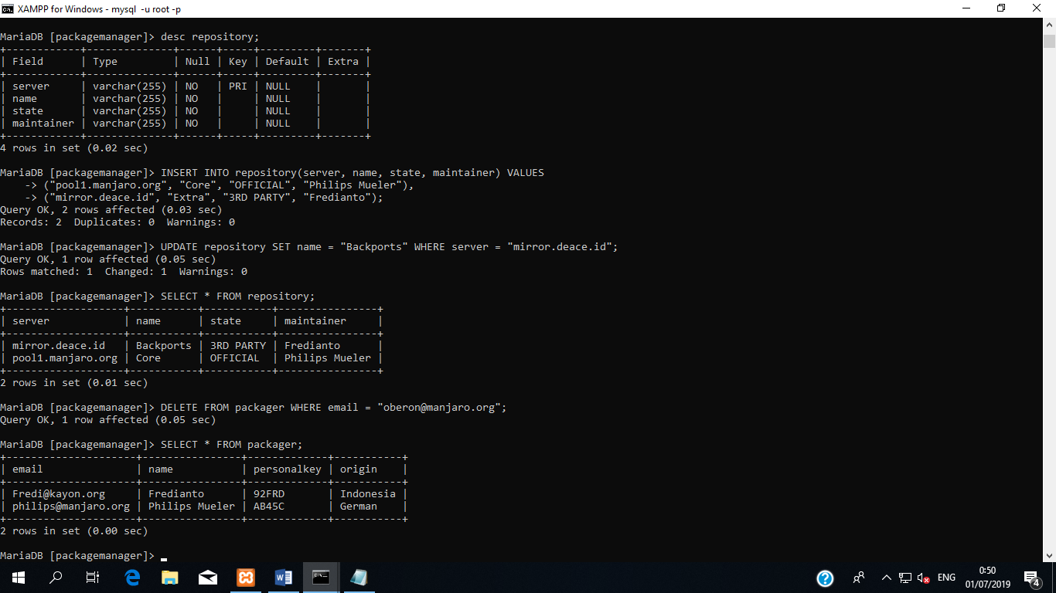

*perintah* ***UPDATE*** *dan* ***DELETE***

(3)

